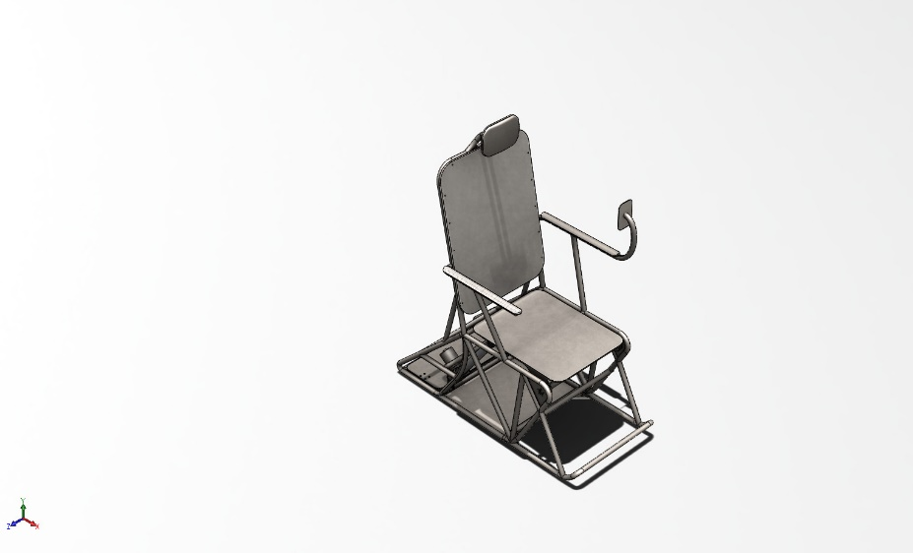 | Simulation of ASSEM6  Date: Tuesday, January 7, 2025  Designer: Solidworks  Study name: Static 1  Analysis type: Static  Table of Contents  Description 1  Assumptions 2  Model Information 3  Study Properties 7  Units 7  Material Properties 8  Loads and Fixtures 9  Connector Definitions 10  Interaction Information 19  Mesh information 19  Sensor Details 19  Resultant Forces 20  Beams 20  Study Results 21  Conclusion 24

Description
No Data

Assumptions

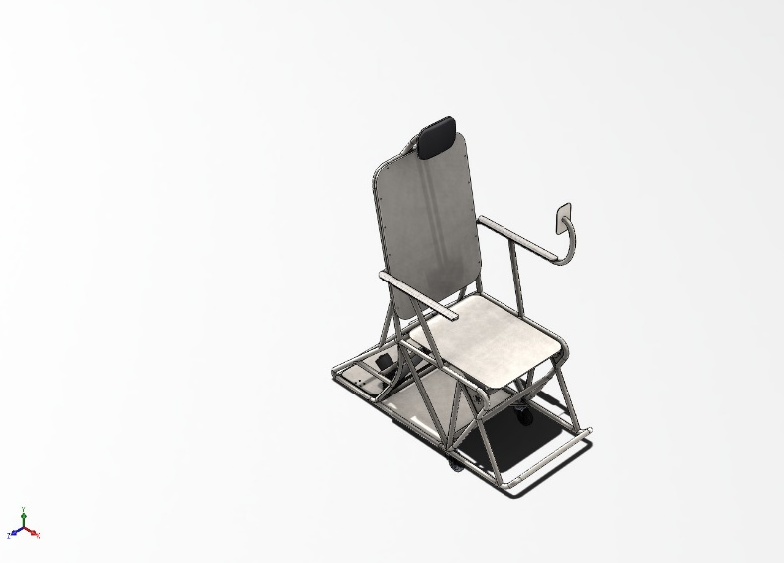  Original Model | 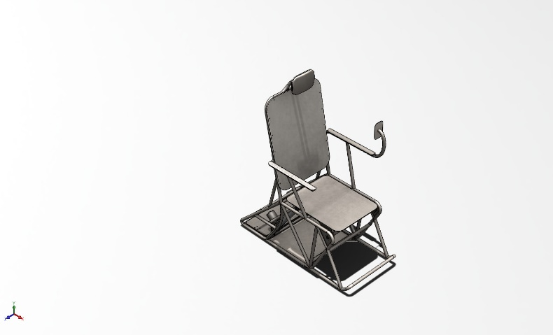  Model Analyzed

Model Information

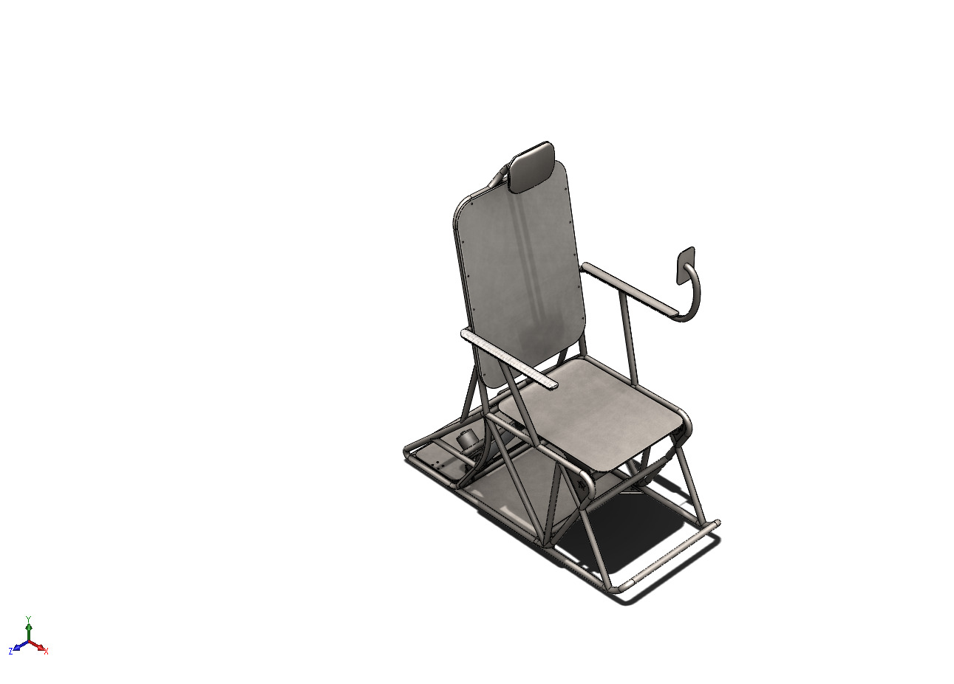
Model name: ASSEM6
Current Configuration: Default
Solid Bodies
Document Name and Reference | Treated As | Volumetric Properties | Document Path/Date Modified
Cut-Extrude5  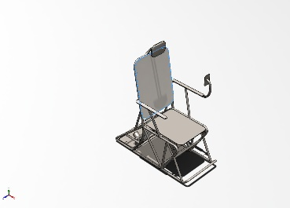 | Solid Body | Mass:27.1035 kg  Volume:0.00344916 m^3  Density:7,858 kg/m^3  Weight:265.614 N | C:\Users\User\Desktop\All BE Designs\Solidworks\jetchair_it5\Back.SLDPRT  Jan 4 16:26:38 2025
Cut-Extrude10  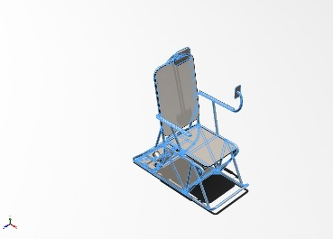 | Solid Body | Mass:34.658 kg  Volume:0.00441029 m^3  Density:7,858.44 kg/m^3  Weight:339.648 N | C:\Users\User\Desktop\All BE Designs\Solidworks\jetchair_it6\Iteration6_chassis.SLDPRT  Jan 7 13:33:24 2025
Split Line1  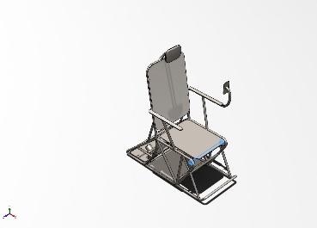 | Solid Body | Mass:0.945003 kg  Volume:0.00012026 m^3  Density:7,858 kg/m^3  Weight:9.26103 N | C:\Users\User\Desktop\All BE Designs\Solidworks\jetchair_it6\PIN_PIPE.SLDPRT  Jan 7 13:33:02 2025
Chamfer4 | Solid Body | Mass:6.38439 kg  Volume:0.00081247 m^3  Density:7,858 kg/m^3  Weight:62.567 N | C:\Users\User\Desktop\All BE Designs\Solidworks\jetchair_it5\RS.177-4516-bottom.SLDPRT  Jan 4 16:51:43 2025
Chamfer2 | Solid Body | Mass:0.222153 kg  Volume:2.82712e-05 m^3  Density:7,857.94 kg/m^3  Weight:2.1771 N | C:\Users\User\Desktop\All BE Designs\Solidworks\jetchair_it5\RS.177-4516-bottom-mount.SLDPRT  Jan 3 20:26:00 2025
Cut-Extrude1 | Solid Body | Mass:1.08053 kg  Volume:0.000137507 m^3  Density:7,858 kg/m^3  Weight:10.5892 N | C:\Users\User\Desktop\All BE Designs\Solidworks\jetchair_it5\RS.177-4516-shaft.SLDPRT  Jan 4 20:40:56 2025
Boss-Extrude2 | Solid Body | Mass:0.169871 kg  Volume:2.16178e-05 m^3  Density:7,857.93 kg/m^3  Weight:1.66473 N | C:\Users\User\Desktop\All BE Designs\Solidworks\jetchair_it5\RS.177-4516-top-mount.SLDPRT  Jan 4 20:40:56 2025
Chamfer4 | Solid Body | Mass:6.38439 kg  Volume:0.00081247 m^3  Density:7,858 kg/m^3  Weight:62.567 N | C:\Users\User\Desktop\All BE Designs\Solidworks\jetchair_it5\RS.177-4516-bottom.SLDPRT  Jan 4 16:51:43 2025
Chamfer2 | Solid Body | Mass:0.222153 kg  Volume:2.82712e-05 m^3  Density:7,857.94 kg/m^3  Weight:2.1771 N | C:\Users\User\Desktop\All BE Designs\Solidworks\jetchair_it5\RS.177-4516-bottom-mount.SLDPRT  Jan 3 20:26:00 2025
Cut-Extrude1 | Solid Body | Mass:1.08053 kg  Volume:0.000137507 m^3  Density:7,858 kg/m^3  Weight:10.5892 N | C:\Users\User\Desktop\All BE Designs\Solidworks\jetchair_it5\RS.177-4516-shaft.SLDPRT  Jan 4 20:40:56 2025
Boss-Extrude2 | Solid Body | Mass:0.169871 kg  Volume:2.16178e-05 m^3  Density:7,857.93 kg/m^3  Weight:1.66473 N | C:\Users\User\Desktop\All BE Designs\Solidworks\jetchair_it5\RS.177-4516-top-mount.SLDPRT  Jan 4 20:40:56 2025
Fillet5  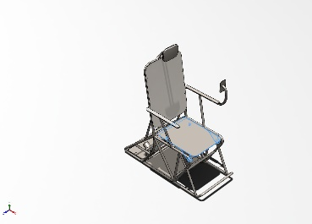 | Solid Body | Mass:9.08162 kg  Volume:0.00115572 m^3  Density:7,858 kg/m^3  Weight:88.9999 N | C:\Users\User\Desktop\All BE Designs\Solidworks\jetchair_it6\butt_cushion_v3.SLDPRT  Jan 7 13:33:24 2025
OuterRace  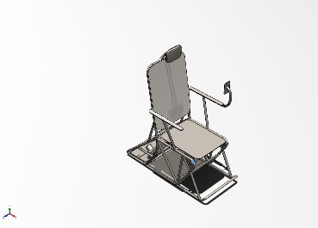 | Solid Body | Mass:0.00926628 kg  Volume:1.17922e-06 m^3  Density:7,858 kg/m^3  Weight:0.0908095 N | C:\SOLIDWORKS Data (2)\browser\Ansi Metric\bearings\ball bearings\instrument ball bearing_68_am.sldprt  Jan 7 13:27:12 2025
OuterRace  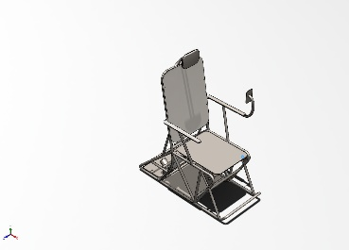 | Solid Body | Mass:0.00926628 kg  Volume:1.17922e-06 m^3  Density:7,858 kg/m^3  Weight:0.0908095 N | C:\SOLIDWORKS Data (2)\browser\Ansi Metric\bearings\ball bearings\instrument ball bearing_68_am.sldprt  Jan 7 13:27:12 2025

Study Properties
Study name | Static 1
Analysis type | Static
Mesh type | Mixed Mesh
Thermal Effect: | On
Thermal option | Include temperature loads
Zero strain temperature | 298 Kelvin
Include fluid pressure effects from SOLIDWORKS Flow Simulation | Off
Solver type | Automatic
Inplane Effect: | Off
Soft Spring: | Off
Inertial Relief: | Off
Incompatible bonding options | Automatic
Large displacement | Off
Compute free body forces | On
Friction | Off
Use Adaptive Method: | Off
Result folder | SOLIDWORKS document (C:\Users\User\Desktop\All BE Designs\Solidworks\jetchair_it6)

Units
Unit system: | SI (MKS)
Length/Displacement | mm
Temperature | Kelvin
Angular velocity | Rad/sec
Pressure/Stress | N/m^2

Material Properties
Model Reference | Properties | Components
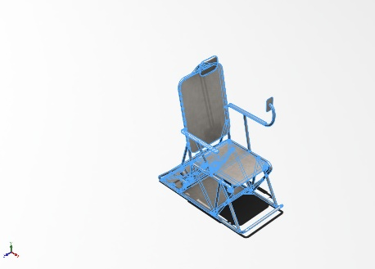 | Name: 1023 Carbon Steel Sheet (SS)  Model type: Linear Elastic Isotropic  Default failure criterion: Max von Mises Stress  Yield strength: 2.82685e+08 N/m^2  Tensile strength: 4.25e+08 N/m^2  Elastic modulus: 2.05e+11 N/m^2  Poisson's ratio: 0.29  Mass density: 7,858 kg/m^3  Shear modulus: 8e+10 N/m^2  Thermal expansion coefficient: 1.2e-05 /Kelvin | SolidBody 1(Cut-Extrude5)(Back-1),  SolidBody 1(Mirror50)(Iteration6_chassis-1),  SolidBody 2(Cut-Extrude10)(Iteration6_chassis-1),  SolidBody 3(Fillet33)(Iteration6_chassis-1),  SolidBody 4(Cut-Extrude8)(Iteration6_chassis-1),  SolidBody 1(Split Line1)(PIN_PIPE-1),  SolidBody 1(Chamfer4)(RS.177-4516-3000N-1/RS.177-4516-bottom-1),  SolidBody 1(Chamfer2)(RS.177-4516-3000N-1/RS.177-4516-bottom-mount-1),  SolidBody 1(Cut-Extrude1)(RS.177-4516-3000N-1/RS.177-4516-shaft-1),  SolidBody 1(Boss-Extrude2)(RS.177-4516-3000N-1/RS.177-4516-top-mount-1),  SolidBody 1(Chamfer4)(RS.177-4516-3000N-2/RS.177-4516-bottom-1),  SolidBody 1(Chamfer2)(RS.177-4516-3000N-2/RS.177-4516-bottom-mount-1),  SolidBody 1(Cut-Extrude1)(RS.177-4516-3000N-2/RS.177-4516-shaft-1),  SolidBody 1(Boss-Extrude2)(RS.177-4516-3000N-2/RS.177-4516-top-mount-1),  SolidBody 2(Fillet5)(butt_cushion_v3-1),  SolidBody 1(OuterRace)(instrument ball bearing_68_am-1),  SolidBody 1(OuterRace)(instrument ball bearing_68_am-2)
Curve Data:N/A

Loads and Fixtures
Fixture name | Fixture Image | Fixture Details
Fixed-1 | 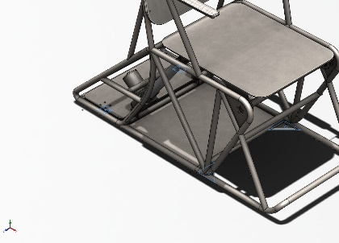 | Entities: 4 face(s)  Type: Fixed Geometry
Resultant Forces
Components | X | Y | Z | Resultant
Reaction force(N) | 3.74359 | 5,999.99 | 7.09295e-05 | 6,000
Reaction Moment(N.m) | 0 | 0 | 0 | 1e-33

Load name | Load Image | Load Details
Force-3 | 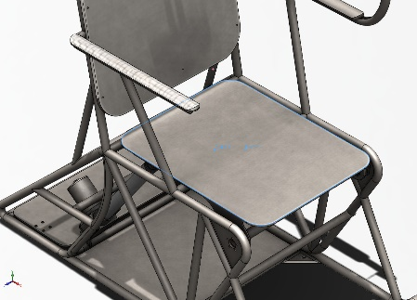 | Entities: 1 face(s), 1 Point Load(s)  Reference: Edge< 1 >  Type: Apply force  Values: ---, ---, 3,000 N  Moments: ---, ---, --- N.m

Connector Definitions

Connector Name | Connector Details | Connector Image
Rigid Connector-19 | Entities: 4 face(s)  Type: Rigid | 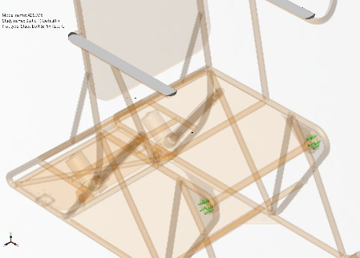  Rigid Connector-19

Pin/Bolt/Bearing Connector
Model Reference | Connector Details | Strength Details
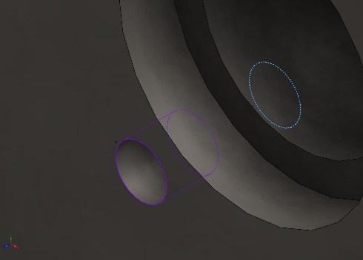  B18.6.7M - M5 x 0.8 x 20 Indented HHMS --20N - 1 | Entities: 1 edge(s), 1 face(s)  Type: Bolt(Head/Nut diameter)(Counterbore screw)  Connection Type: Distributed  Head diameter: 8 mm  Nominal shank diameter: 5 mm  Material name: Alloy Steel  Young's modulus: 2.1e+11 N/m^2  Poisson's ratio: 0.28  Tensile Stress Area: 14.1825 mm^2  Bolt Strength: 6.20422e+08 N/m^2  Safety Factor: 2  Preload (Axial): 1,319.87 N  Friction Factor (K): 0.2  Tight Fit: No | Bolt Check: OK  Calculated FOS: 6.43658  Desired FOS: 2  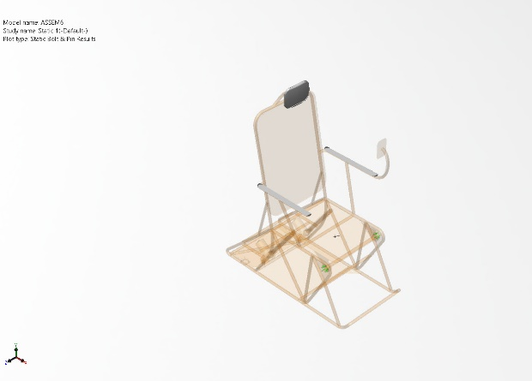
Connector Forces
Type | X-Component | Y-Component | Z-Component | Resultant
Axial Force (N) | 0 | 0 | -1,334.6 | 1,334.6
Shear Force (N) | -2.6905 | -3.3602 | 0 | 4.3046
Bending moment (N.m) | 0.022315 | -0.017113 | 0 | 0.028121

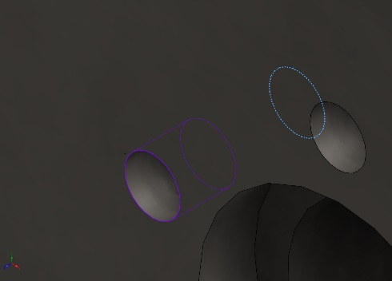  B18.6.7M - M5 x 0.8 x 20 Indented HHMS --20N - 2 | Entities: 1 edge(s), 1 face(s)  Type: Bolt(Head/Nut diameter)(Counterbore screw)  Connection Type: Distributed  Head diameter: 8 mm  Nominal shank diameter: 5 mm  Material name: Alloy Steel  Young's modulus: 2.1e+11 N/m^2  Poisson's ratio: 0.28  Tensile Stress Area: 14.1825 mm^2  Bolt Strength: 6.20422e+08 N/m^2  Safety Factor: 2  Preload (Axial): 1,319.87 N  Friction Factor (K): 0.2  Tight Fit: No | Bolt Check: OK  Calculated FOS: 6.20609  Desired FOS: 2  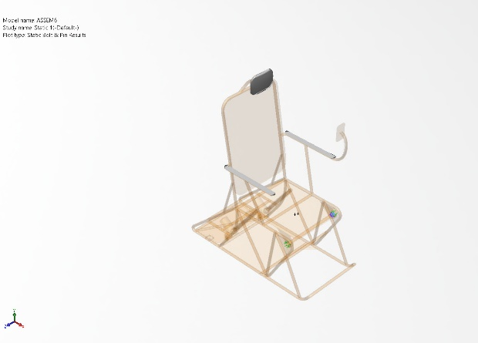
Connector Forces
Type | X-Component | Y-Component | Z-Component | Resultant
Axial Force (N) | 0 | 0 | -1,316.8 | 1,316.8
Shear Force (N) | 11.546 | -5.0834 | 0 | 12.616
Bending moment (N.m) | 0.037055 | 0.07917 | 0 | 0.087412

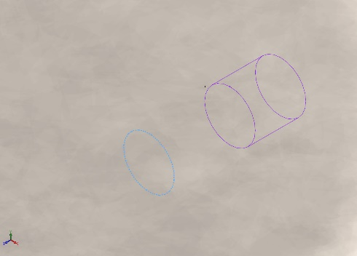  B18.6.7M - M5 x 0.8 x 20 Indented HHMS --20N - 3 | Entities: 1 edge(s), 1 face(s)  Type: Bolt(Head/Nut diameter)(Counterbore screw)  Connection Type: Distributed  Head diameter: 8 mm  Nominal shank diameter: 5 mm  Material name: Alloy Steel  Young's modulus: 2.1e+11 N/m^2  Poisson's ratio: 0.28  Tensile Stress Area: 14.1825 mm^2  Bolt Strength: 6.20422e+08 N/m^2  Safety Factor: 2  Preload (Axial): 1,319.87 N  Friction Factor (K): 0.2  Tight Fit: No | Bolt Check: OK  Calculated FOS: 6.14885  Desired FOS: 2  
Connector Forces
Type | X-Component | Y-Component | Z-Component | Resultant
Axial Force (N) | 0 | 0 | 1,313.8 | 1,313.8
Shear Force (N) | 2.5819 | -14.187 | 0 | 14.42
Bending moment (N.m) | -0.10012 | -0.016472 | 0 | 0.10147

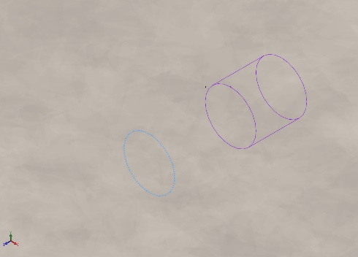  B18.6.7M - M5 x 0.8 x 20 Indented HHMS --20N - 4 | Entities: 1 edge(s), 1 face(s)  Type: Bolt(Head/Nut diameter)(Counterbore screw)  Connection Type: Distributed  Head diameter: 8 mm  Nominal shank diameter: 5 mm  Material name: Alloy Steel  Young's modulus: 2.1e+11 N/m^2  Poisson's ratio: 0.28  Tensile Stress Area: 14.1825 mm^2  Bolt Strength: 6.20422e+08 N/m^2  Safety Factor: 2  Preload (Axial): 1,319.87 N  Friction Factor (K): 0.2  Tight Fit: No | Bolt Check: OK  Calculated FOS: 6.26662  Desired FOS: 2  
Connector Forces
Type | X-Component | Y-Component | Z-Component | Resultant
Axial Force (N) | 0 | 0 | 1,316.8 | 1,316.8
Shear Force (N) | 12.224 | -3.0584 | 0 | 12.601
Bending moment (N.m) | -0.029151 | -0.069676 | 0 | 0.075529

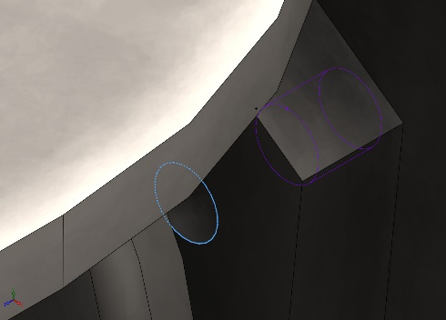  B18.6.7M - M5 x 0.8 x 20 Indented HHMS --20N - 5 | Entities: 1 edge(s), 1 face(s)  Type: Bolt(Head/Nut diameter)(Counterbore screw)  Connection Type: Distributed  Head diameter: 8 mm  Nominal shank diameter: 5 mm  Material name: Alloy Steel  Young's modulus: 2.1e+11 N/m^2  Poisson's ratio: 0.28  Tensile Stress Area: 14.1825 mm^2  Bolt Strength: 6.20422e+08 N/m^2  Safety Factor: 2  Preload (Axial): 1,319.87 N  Friction Factor (K): 0.2  Tight Fit: No | Bolt Check: OK  Calculated FOS: 6.38105  Desired FOS: 2  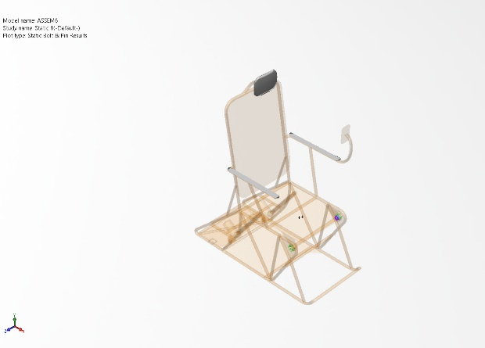
Connector Forces
Type | X-Component | Y-Component | Z-Component | Resultant
Axial Force (N) | 0 | 0 | 1,319.3 | 1,319.3
Shear Force (N) | -8.5321 | -1.2761 | 0 | 8.6271
Bending moment (N.m) | -0.002557 | 0.05153 | 0 | 0.051594

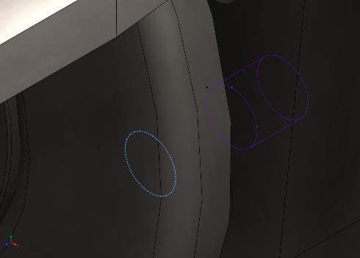  B18.6.7M - M5 x 0.8 x 20 Indented HHMS --20N - 6 | Entities: 1 edge(s), 1 face(s)  Type: Bolt(Head/Nut diameter)(Counterbore screw)  Connection Type: Distributed  Head diameter: 8 mm  Nominal shank diameter: 5 mm  Material name: Alloy Steel  Young's modulus: 2.1e+11 N/m^2  Poisson's ratio: 0.28  Tensile Stress Area: 14.1825 mm^2  Bolt Strength: 6.20422e+08 N/m^2  Safety Factor: 2  Preload (Axial): 1,319.87 N  Friction Factor (K): 0.2  Tight Fit: No | Bolt Check: OK  Calculated FOS: 6.55745  Desired FOS: 2  
Connector Forces
Type | X-Component | Y-Component | Z-Component | Resultant
Axial Force (N) | 0 | 0 | 1,332.7 | 1,332.7
Shear Force (N) | 2.3209 | -1.6997 | 0 | 2.8767
Bending moment (N.m) | -0.0074828 | -0.0025768 | 0 | 0.007914

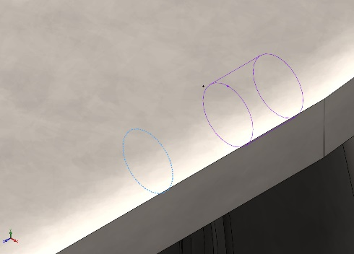  B18.6.7M - M5 x 0.8 x 20 Indented HHMS --20N - 7 | Entities: 1 edge(s), 1 face(s)  Type: Bolt(Head/Nut diameter)(Counterbore screw)  Connection Type: Distributed  Head diameter: 8 mm  Nominal shank diameter: 5 mm  Material name: Alloy Steel  Young's modulus: 2.1e+11 N/m^2  Poisson's ratio: 0.28  Tensile Stress Area: 14.1825 mm^2  Bolt Strength: 6.20422e+08 N/m^2  Safety Factor: 2  Preload (Axial): 1,319.87 N  Friction Factor (K): 0.2  Tight Fit: No | Bolt Check: OK  Calculated FOS: 6.48008  Desired FOS: 2  
Connector Forces
Type | X-Component | Y-Component | Z-Component | Resultant
Axial Force (N) | 0 | 0 | 1,334 | 1,334
Shear Force (N) | 0.41788 | -3.159 | 0 | 3.1865
Bending moment (N.m) | -0.02009 | 0.004812 | 0 | 0.020658

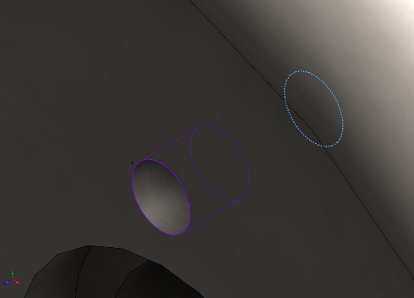  B18.6.7M - M5 x 0.8 x 20 Indented HHMS --20N - 8 | Entities: 1 edge(s), 1 face(s)  Type: Bolt(Head/Nut diameter)(Counterbore screw)  Connection Type: Distributed  Head diameter: 8 mm  Nominal shank diameter: 5 mm  Material name: Alloy Steel  Young's modulus: 2.1e+11 N/m^2  Poisson's ratio: 0.28  Tensile Stress Area: 14.1825 mm^2  Bolt Strength: 6.20422e+08 N/m^2  Safety Factor: 2  Preload (Axial): 1,319.87 N  Friction Factor (K): 0.2  Tight Fit: No | Bolt Check: OK  Calculated FOS: 6.18761  Desired FOS: 2  
Connector Forces
Type | X-Component | Y-Component | Z-Component | Resultant
Axial Force (N) | 0 | 0 | -1,313.3 | 1,313.3
Shear Force (N) | 3.2479 | -13.019 | 0 | 13.418
Bending moment (N.m) | 0.091817 | 0.020774 | 0 | 0.094138

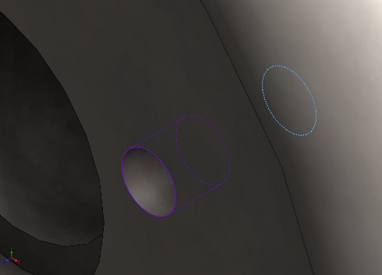  B18.6.7M - M5 x 0.8 x 20 Indented HHMS --20N - 9 | Entities: 1 edge(s), 1 face(s)  Type: Bolt(Head/Nut diameter)(Counterbore screw)  Connection Type: Distributed  Head diameter: 8 mm  Nominal shank diameter: 5 mm  Material name: Alloy Steel  Young's modulus: 2.1e+11 N/m^2  Poisson's ratio: 0.28  Tensile Stress Area: 14.1825 mm^2  Bolt Strength: 6.20422e+08 N/m^2  Safety Factor: 2  Preload (Axial): 1,319.87 N  Friction Factor (K): 0.2  Tight Fit: No | Bolt Check: OK  Calculated FOS: 6.27855  Desired FOS: 2  
Connector Forces
Type | X-Component | Y-Component | Z-Component | Resultant
Axial Force (N) | 0 | 0 | -1,320 | 1,320
Shear Force (N) | -9.3879 | 3.7187 | 0 | 10.098
Bending moment (N.m) | -0.021114 | -0.067291 | 0 | 0.070526

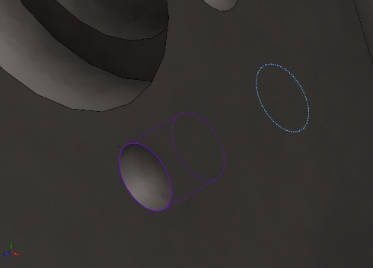  B18.6.7M - M5 x 0.8 x 20 Indented HHMS --20N - 10 | Entities: 1 edge(s), 1 face(s)  Type: Bolt(Head/Nut diameter)(Counterbore screw)  Connection Type: Distributed  Head diameter: 8 mm  Nominal shank diameter: 5 mm  Material name: Alloy Steel  Young's modulus: 2.1e+11 N/m^2  Poisson's ratio: 0.28  Tensile Stress Area: 14.1825 mm^2  Bolt Strength: 6.20422e+08 N/m^2  Safety Factor: 2  Preload (Axial): 1,319.87 N  Friction Factor (K): 0.2  Tight Fit: No | Bolt Check: OK  Calculated FOS: 6.45585  Desired FOS: 2  
Connector Forces
Type | X-Component | Y-Component | Z-Component | Resultant
Axial Force (N) | 0 | 0 | -1,333 | 1,333
Shear Force (N) | 2.3451 | -3.933 | 0 | 4.5791
Bending moment (N.m) | 0.025726 | 0.0030406 | 0 | 0.025905

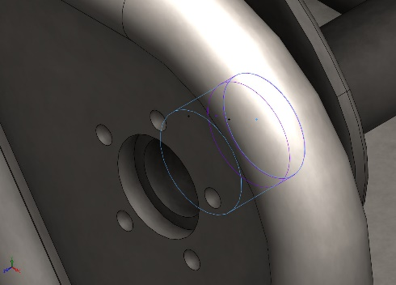  Bearing Connector-19 | Entities: 2 face(s)  Type: Bearing | No Data
Connector Forces
Type | X-Component | Y-Component | Z-Component | Resultant
Axial Force (N) | -0 | -0 | -77.08 | -77.08
Shear Force (N) | 31.581 | 1,187.9 | 0 | 1,188.3
Bending moment (N.m) | -0.011877 | 0.00031576 | 0 | 0.011881

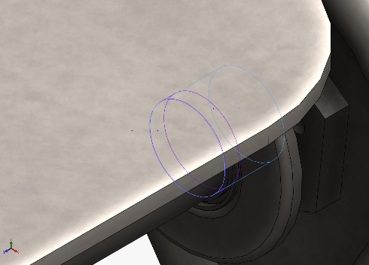  Bearing Connector-20 | Entities: 2 face(s)  Type: Bearing | No Data
Connector Forces
Type | X-Component | Y-Component | Z-Component | Resultant
Axial Force (N) | 0 | 0 | 105.58 | 105.58
Shear Force (N) | 31.436 | 1,026.5 | 0 | 1,027
Bending moment (N.m) | -0.010264 | 0.00031432 | 0 | 0.010269

Interaction Information

Interaction | Interaction Image | Interaction Properties
Global Interaction | 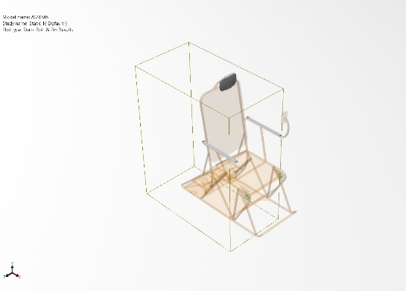 | Type: Bonded  Components: 1 component(s)  Options: Independent mesh

Mesh information
Mesh type | Mixed Mesh
Mesher Used: | Blended curvature-based mesh
Jacobian points for High quality mesh | 16 Points
Jacobian check for shell | Off
Maximum element size | 99.7904 mm
Minimum element size | 4.98952 mm
Mesh Quality | High

Sensor Details
No Data

Resultant Forces

Reaction forces
Selection set | Units | Sum X | Sum Y | Sum Z | Resultant
Entire Model | N | 3.74359 | 5,999.99 | 7.09295e-05 | 6,000

Reaction Moments
Selection set | Units | Sum X | Sum Y | Sum Z | Resultant
Entire Model | N.m | 0 | 0 | 0 | 1e-33

Free body forces
Selection set | Units | Sum X | Sum Y | Sum Z | Resultant
Entire Model | N | -0.000640078 | -0.00186754 | -0.00182392 | 0.00268777

Free body moments
Selection set | Units | Sum X | Sum Y | Sum Z | Resultant
Entire Model | N.m | 0.978535 | -0.0196284 | 1.88873 | 2.12726

Beams
No Data

Study Results

Name | Type | Min | Max
Stress1 | VON: von Mises Stress | 0.000e+00N/m^2  Node: 9342 | 1.552e+08N/m^2  Node: 94684
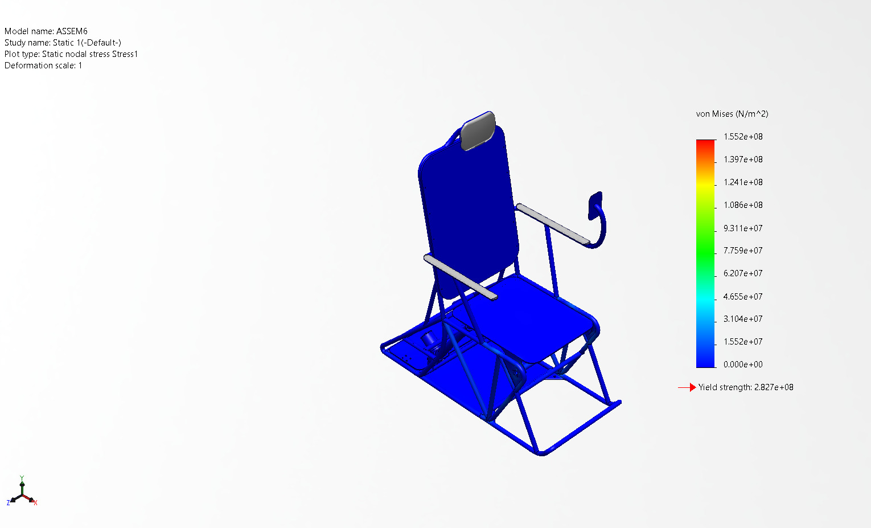
ASSEM6-Static 1-Stress-Stress1

Name | Type | Min | Max
Displacement1 | URES: Resultant Displacement | 0.000e+00mm  Node: 12714 | 1.207e-01mm  Node: 336026
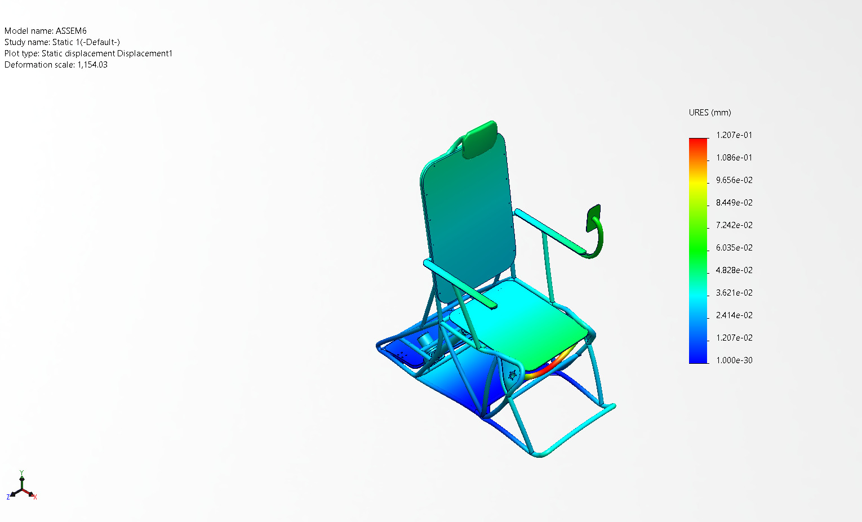
ASSEM6-Static 1-Displacement-Displacement1

Name | Type | Min | Max
Strain1 | ESTRN: Equivalent Strain | 0.000e+00  Element: 4673 | 3.037e-04  Element: 223411
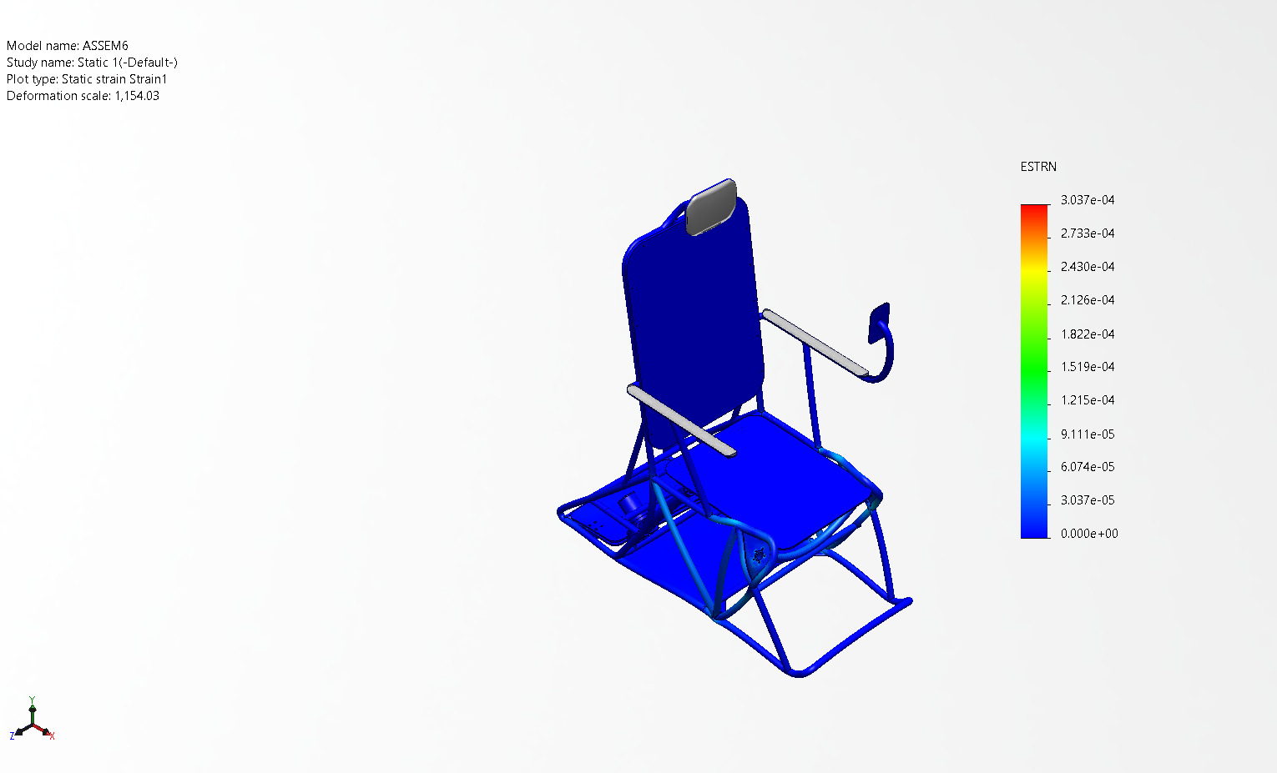
ASSEM6-Static 1-Strain-Strain1

Name | Type | Min | Max
Factor of Safety1 | Automatic | 1.822e+00  Node: 94684 | 1.000e+16  Node: 12116
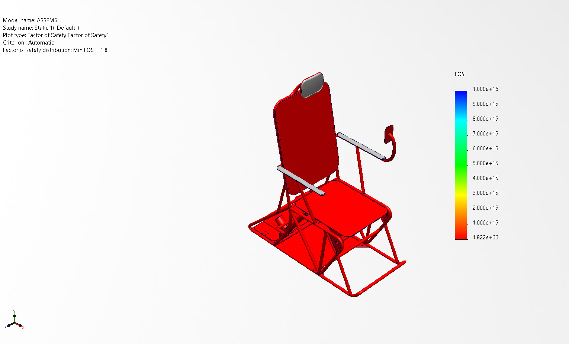
ASSEM6-Static 1-Factor of Safety-Factor of Safety1

Name | Type
Fatigue Check1 | Fatigue Check Plot
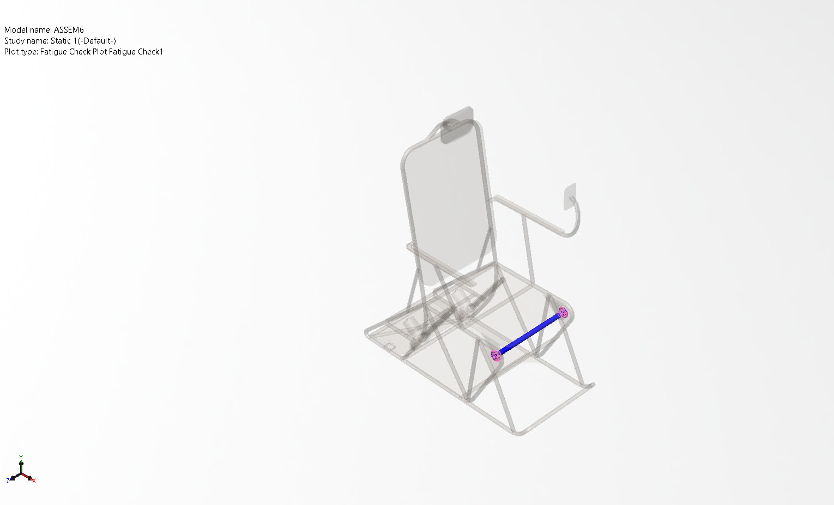
ASSEM6-Static 1-Fatigue Check-Fatigue Check1

Conclusion

